Plan View

186 m

0 m

320 m

FBP X

FBP Y

FBP Z

FCS X

FCS Y

FCS Z

Fire line

Road

320 m

160 m

300 m

250 m

150 m

100 m

50 m

Time averaged velocity

|  |
| --- |
| 0.5 m grid (50s-379s) |
| 0.75 m grid (50s-320s) |
| 1 m grid (50s-550s) |

Devices

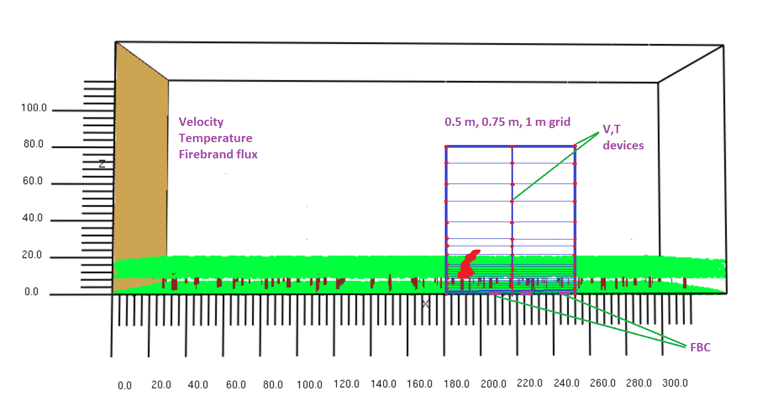

Time-averaged GCI

|  |  |  |  |  |
| --- | --- | --- | --- | --- |
|  | Height 0 m to 80 m | | | |
| Location(m) | Єrms(0.75/0.5) | Єrms(1.00/0.75) | GCI (0.75/0.50) | GCI (1.00/0.75) |
| 182 | 0.15255 | 0.19713 | 36.6 | 76.0 |
| 217 | 0.11552 | 0.13267 | 27.7 | 51.2 |
| 252 | 0.12356 | 0.14225 | 29.7 | 54.9 |

----------------------------------------------------------------------------------------------------------------------

|  |  |  |  |  |
| --- | --- | --- | --- | --- |
|  | Height 40 m to 80 m | | | |
| Location(m) | Єrms(0.75/0.5) | Єrms(1.00/0.75) | GCI (0.75/0.50) | GCI (1.00/0.75) |
| 182 | 0.00987 | 0.03512 | 2.4 | 13.5 |
| 217 | 0.02570 | 0.04954 | 6.2 | 19.1 |
| 252 | 0.03873 | 0.06241 | 9.3 | 24.1 |

----------------------------------------------------------------------------------------------------------------------

|  |  |  |  |  |
| --- | --- | --- | --- | --- |
|  | Height 30 m to 80 m | | | |
| Location(m) | Єrms(0.75/0.5) | Єrms(1.00/0.75) | GCI (0.75/0.50) | GCI (1.00/0.75) |
| 182 | 0.01300 | 0.09812 | 3.1 | 37.8 |
| 217 | 0.02974 | 0.10607 | 7.1 | 40.9 |
| 252 | 0.04180 | 0.12268 | 10.0 | 47.3 |

Time series GCI

|  |  |  |  |
| --- | --- | --- | --- |
|  |  | GCI | |
| x distance(m) | Height(m) | (0.75/0.50) | (1.00/0.75) |
| 182 | 30 | 83.38 | 134.36 |
| 182 | 40 | 21.65 | 42.38 |
| 182 | 50 | 11.01 | 20.52 |
| 182 | 60 | 9.09 | 23.12 |
| 182 | 70 | 10.02 | 21.89 |
| 182 | 80 | 9.77 | 22.04 |
| 217 | 30 | 89.11 | 155.59 |
| 217 | 40 | 38.16 | 84.51 |
| 217 | 50 | 15.56 | 29.20 |
| 217 | 60 | 12.55 | 21.67 |
| 217 | 70 | 12.98 | 21.36 |
| 217 | 80 | 12.67 | 22.70 |
| 252 | 30 | 93.56 | 165.09 |
| 252 | 40 | 49.04 | 113.66 |
| 252 | 50 | 21.24 | 45.26 |
| 252 | 60 | 12.75 | 23.27 |
| 252 | 70 | 11.17 | 22.07 |
| 252 | 80 | 11.16 | 21.17 |

Average wind velocity (m/s) at anemometer (17 m height)

|  |  |  |
| --- | --- | --- |
| Grid size | Experiment | Simulation 5DTT |
| 0.5 m | 1.4 $±$ 0.6  Occasional gusts up to 4.4 m/s  Lulls of 0.5 m/s | 1.39 |
| 0.75 m | 1.89 |
| 1 m | 1.40 |